Research & Concept Development

# Concept

The concept for my website is a music technology news website targeted primarily at amateur musicians and producers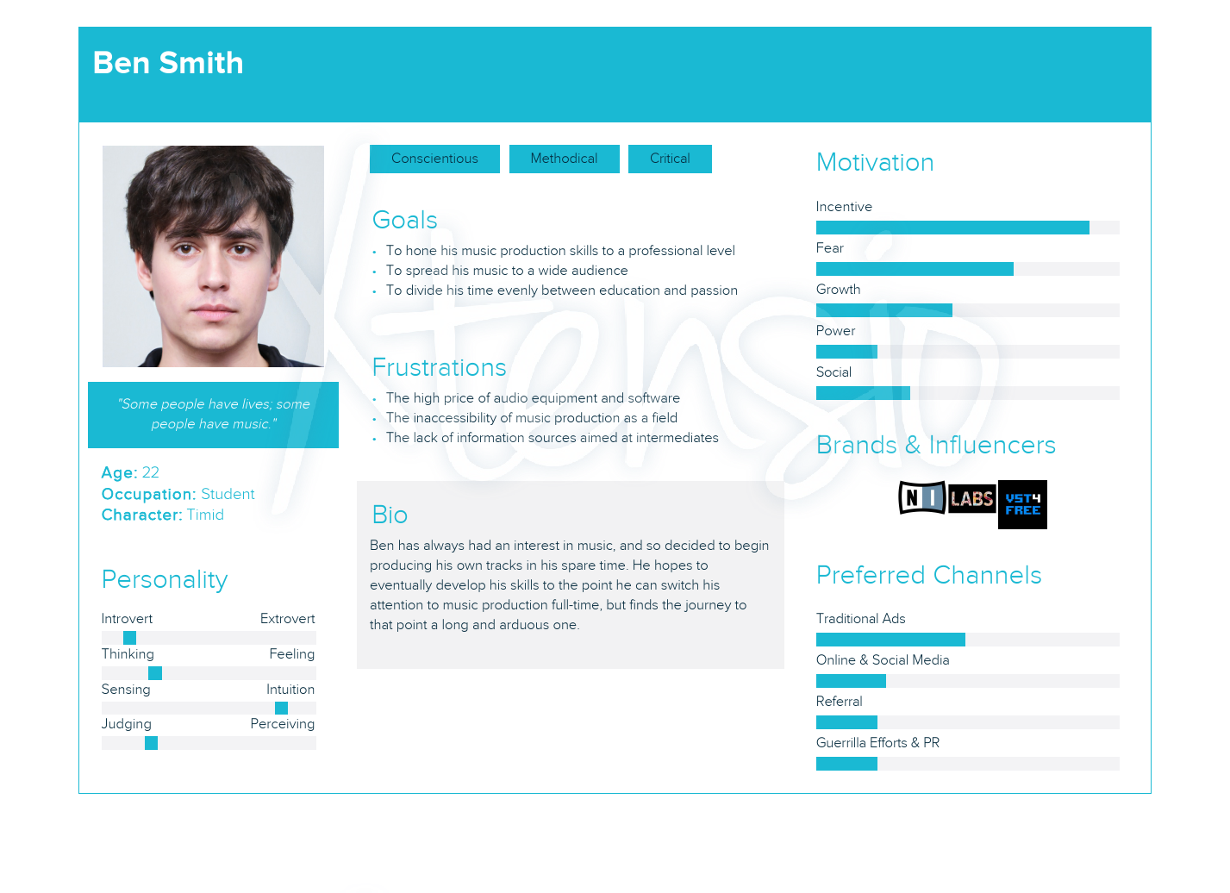

Existing websites on the same topic include musictech.net, musicradar.com and mixonline.com.

# Navigation

Devising a navigation system for a news website turned out to be a surprisingly difficult task – even more so with the idea of user-submitted articles taken into consideration.

In order to design a remotely intuitive navigation system, I thought it best to first separate articles into those submitted by users and those created by the website management (assuming that not all articles would necessarily be user-created).

From that, I decided to use a top navigation bar with the labels ‘Home’, ‘Our Articles’, ‘User Articles’, ‘All News’, ‘Contribute’. Out of these, the ‘Our Articles’, ‘User Articles’ and ‘All News’ would contain a dropdown to further categories ‘Deals’, ‘Reviews’, ‘Opinion’, ‘New Releases’ and ‘Tutorial’, as many websites sort their news by category in the navigation.

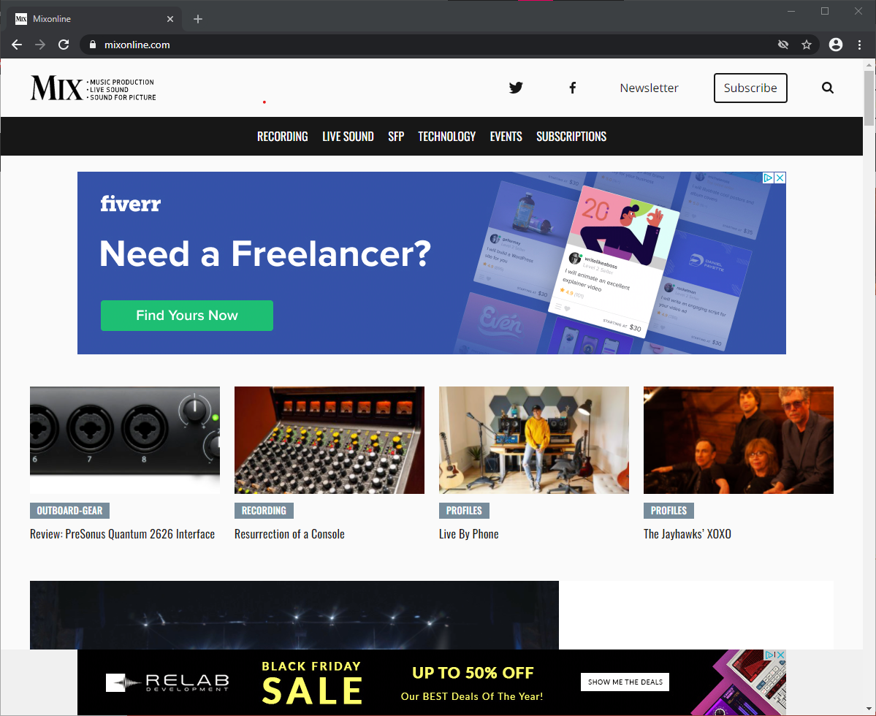

As for the bottom navigation, I included five links typical of what one would normally find in a website footer – ‘About Us’, ‘FAQ’, ‘Privacy Policy’, ‘Terms of Service’ and ‘Contact’.

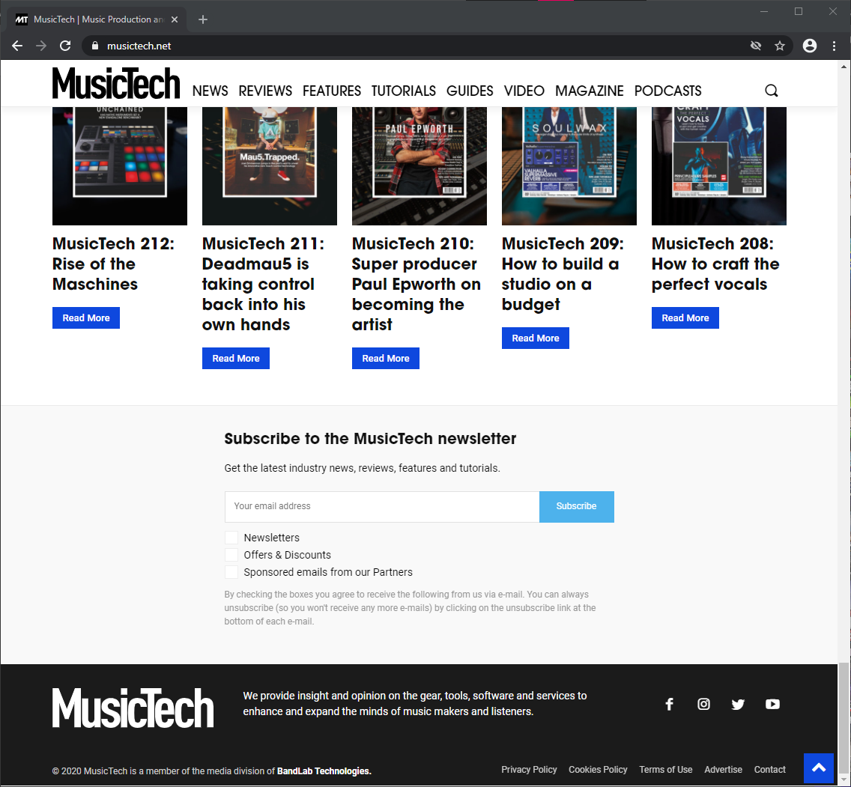

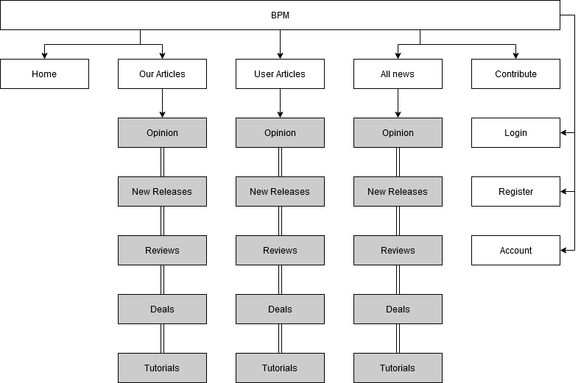

# Branding

Several names were considered for the website, given that there is no shortage of fancy-sounding musical terms – ‘Allegro’, ‘Andante’, ‘Fantasia’, ‘Tutti’, ‘A Piacere’, etc. – but these are all terms that one would find on physical sheet music, and as such didn’t feel particularly cohesive with the concept behind the website, music *technology.*

With this in mind, I switched my focus to terms that are used strictly when talking about digital music. Eventually, I settled on ‘BPM’, or ‘Beats Per Minute’, in part due to the potential for accompanying taglines and in part due to the potential for an ‘electronic’ feeling logo. Since ‘beats per minute’ also has connotations with the heart, designing a logo around the name was a relatively simple affair.



# Colour Scheme

If there is one thing about existing music technology news sites that I find disappointing, it’s that their design aesthetic never particularly evoked ‘music technology’ to me. I suspect this is primarily due to the colour schemes. In both cases, primarily light colour schemes are used – black text on white backgrounds.

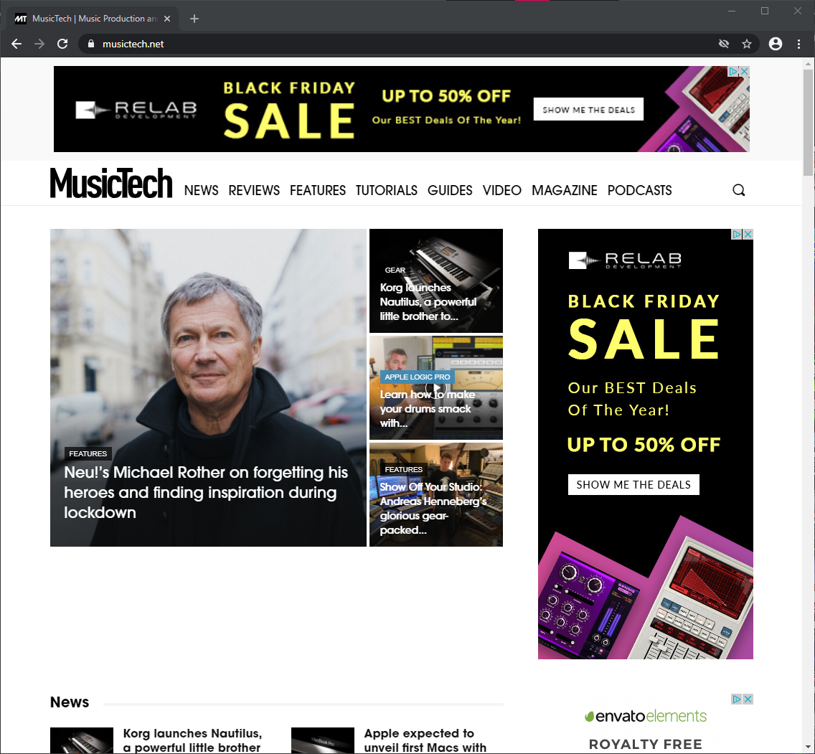



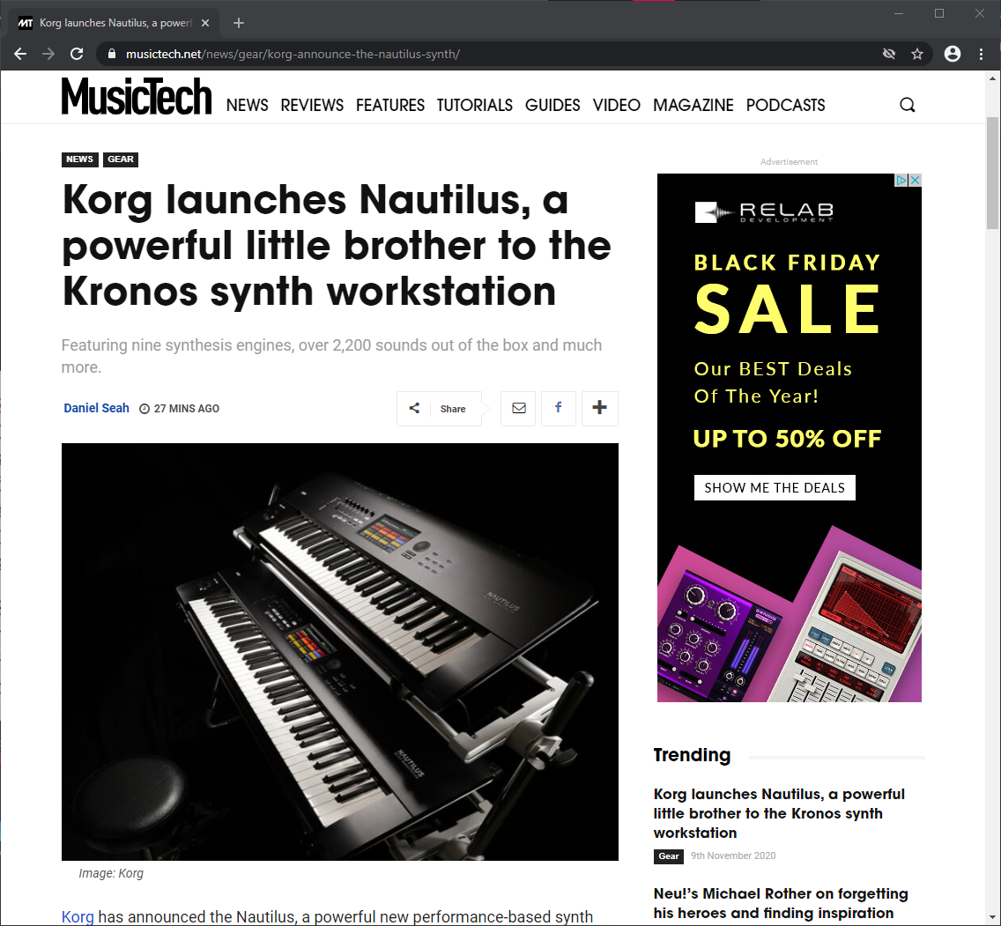

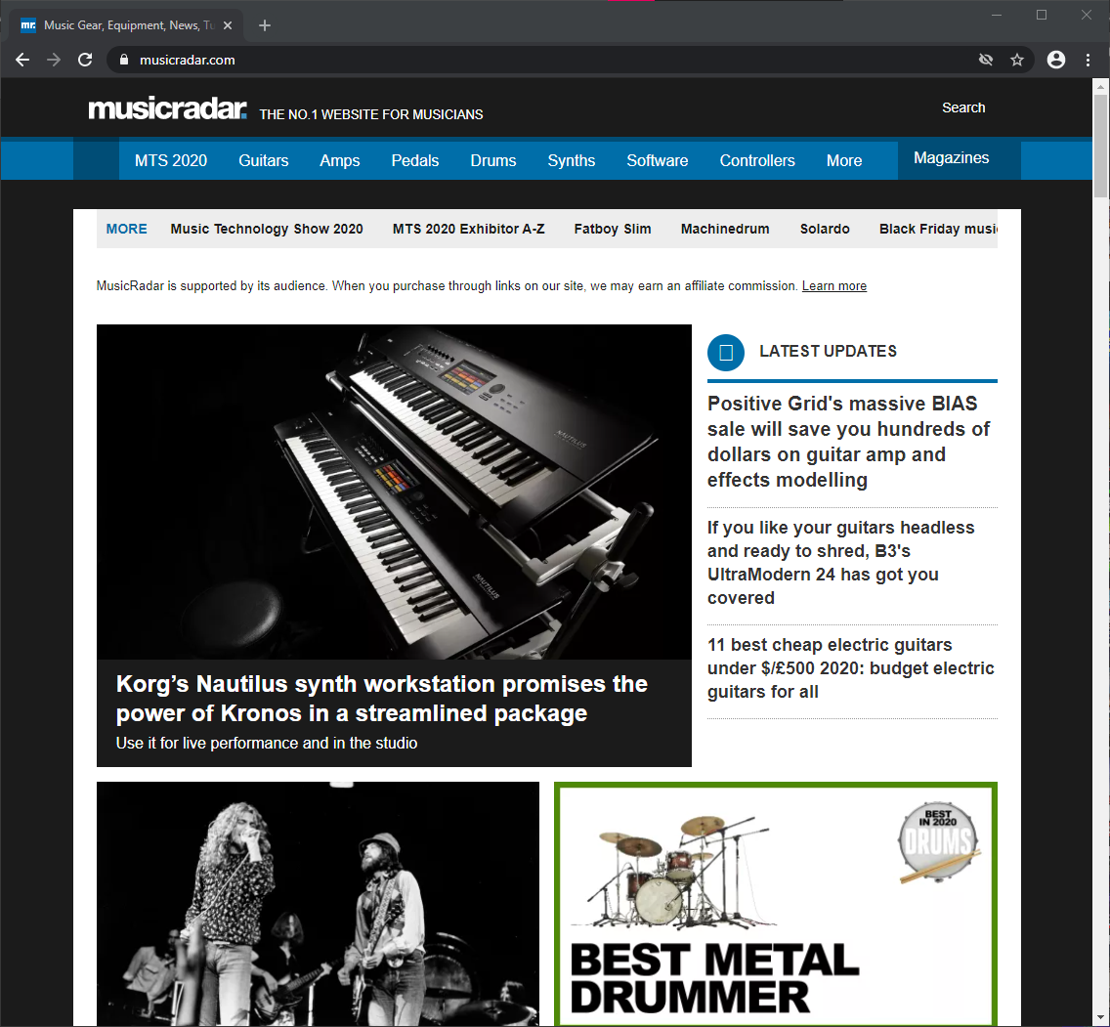

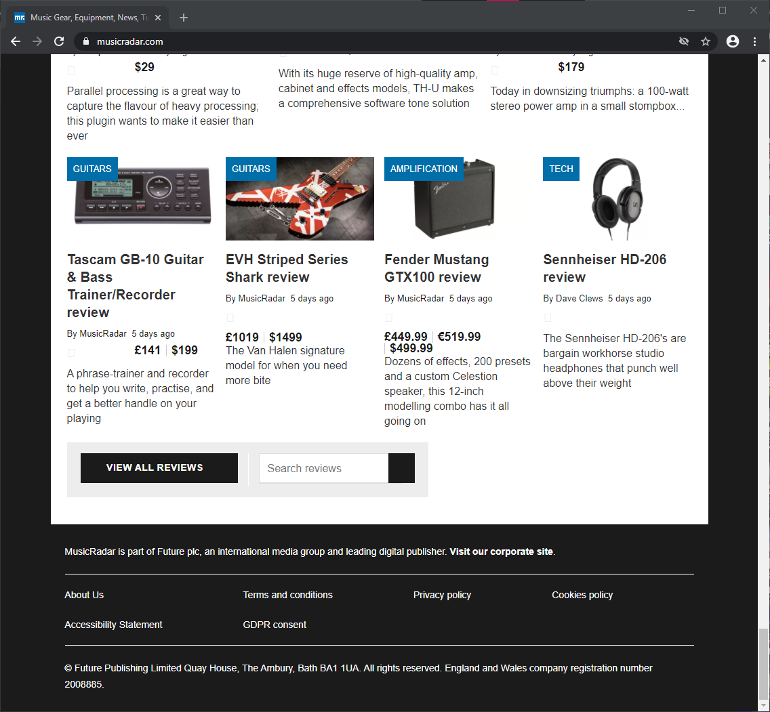

Most music technology, most notably the Digital Audio Workstations that are the most important tools in digital music production, favour dark colour schemes by default, most likely to reduce eye strain when working for long periods of time.

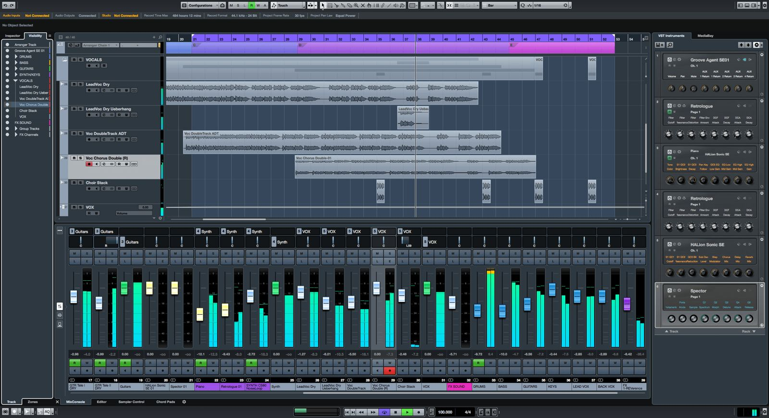

Cubase Interface

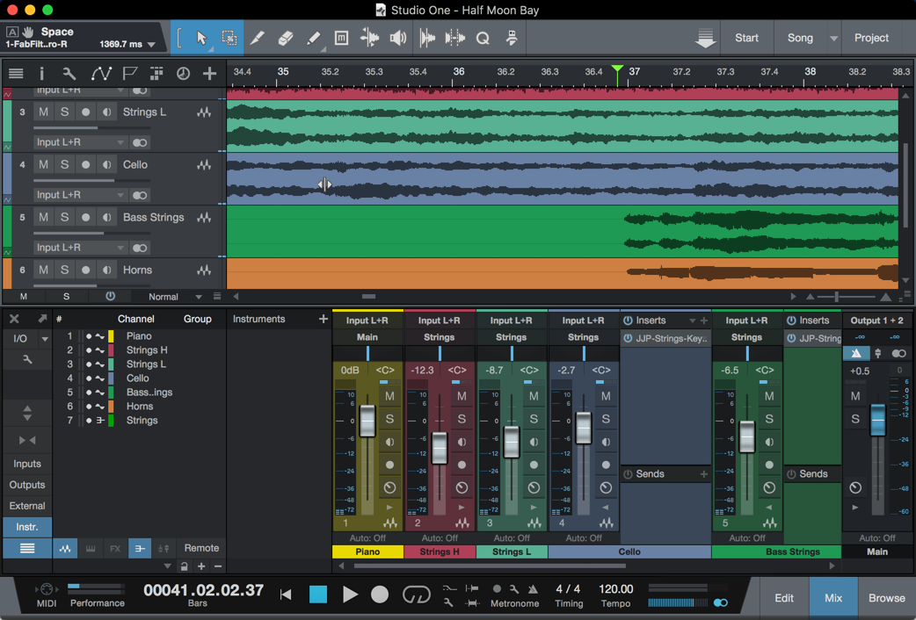

Studio One Interface

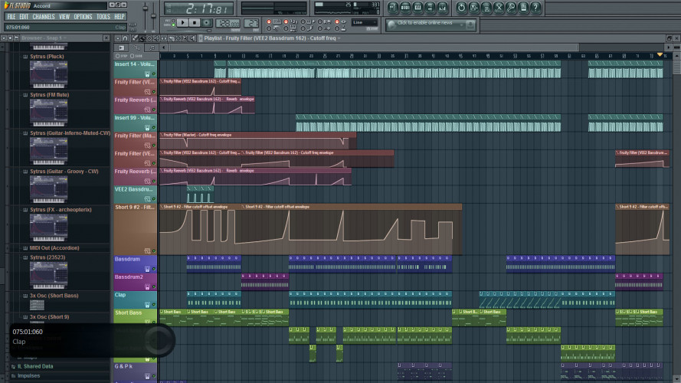

FL Studio Interface

Of course, I realise that news websites of all topics use black-on-white for a reason, that being it is more readable. However, it has been my experience that the more often you use “dark-mode” interfaces, the more difficult it can be to re-adapt to reading “light-mode” interfaces - akin to one’s eyes readjusting after turning on a light in the dark - which often leads me to try to avoid light interfaces where possible. While I hardly have the time needed to conduct a survey, I do not think it is unreasonable to assume that the same may apply to the target audience who may spend quite a lot of their time staring at darker screens.

With this in mind, and also taking into account that “dark-modes” are becoming ‘trendy’ anyway, I have decided that a darker interface may be preferable in this instance.

More specifically, I took inspiration from the interface of a tool called ‘Virtual DJ’, which uses a dark interface of greys, white text, and bright red and electric blue. From this selection, my logo was created.

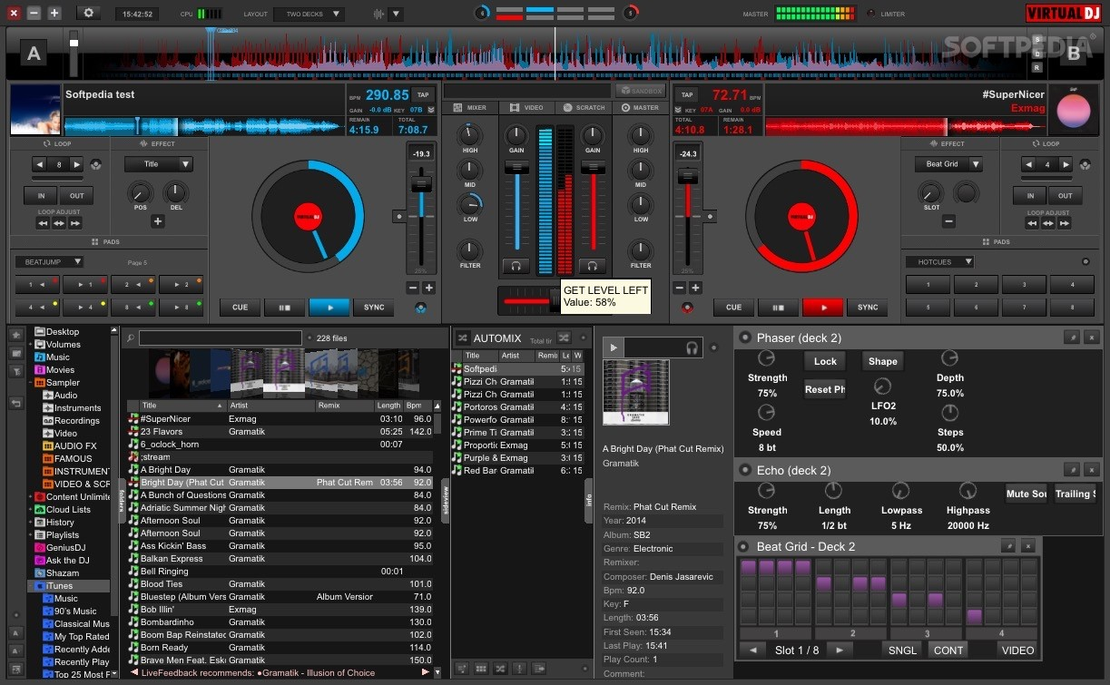





# Layout

The main obstacle when developing a layout for the home page and articles was the requirement of creating ad spaces.



I quite liked MusicTech’s approach of using a sidebar – keeping the ads from interrupting the flow of content while still having them noticeable, so I decided to do just that with the desktop version of the website.

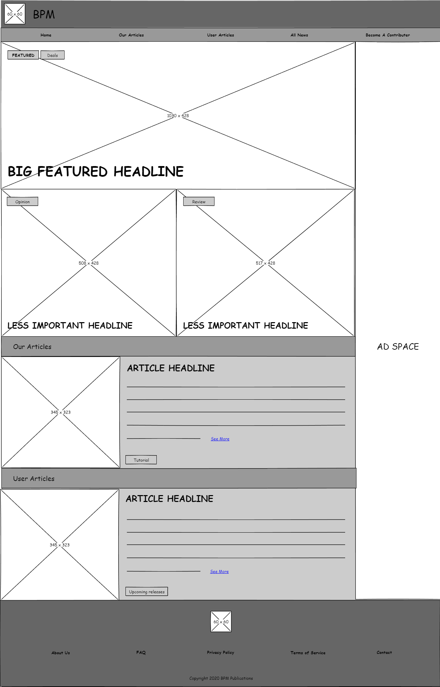

As for the remainder of the homepage layout for both desktop and mobile, that was mostly inspired by MusicTech as well, but uses a slightly stricter grid again to avoid interrupting the flow of content down the page.

It is worth noting that in theory the ‘Our Articles’ and ‘User Articles’ sections would contain more than one article, but with only five unique articles I thought it best to just give them one each.

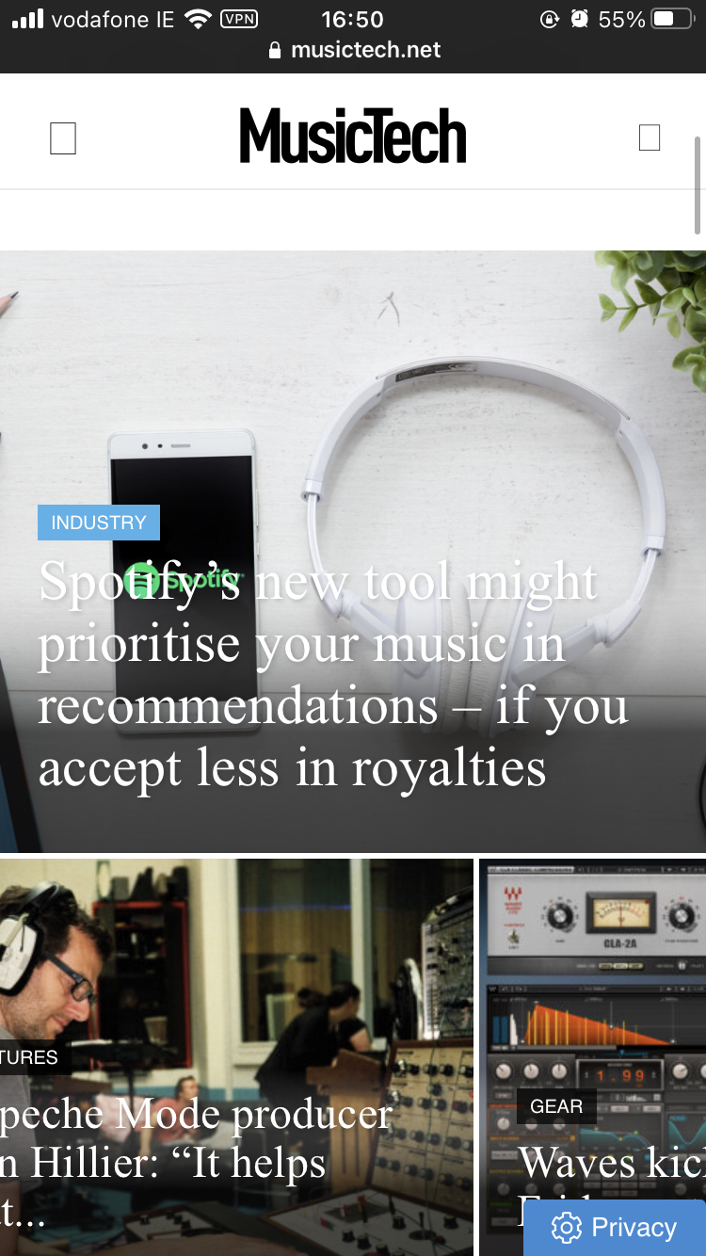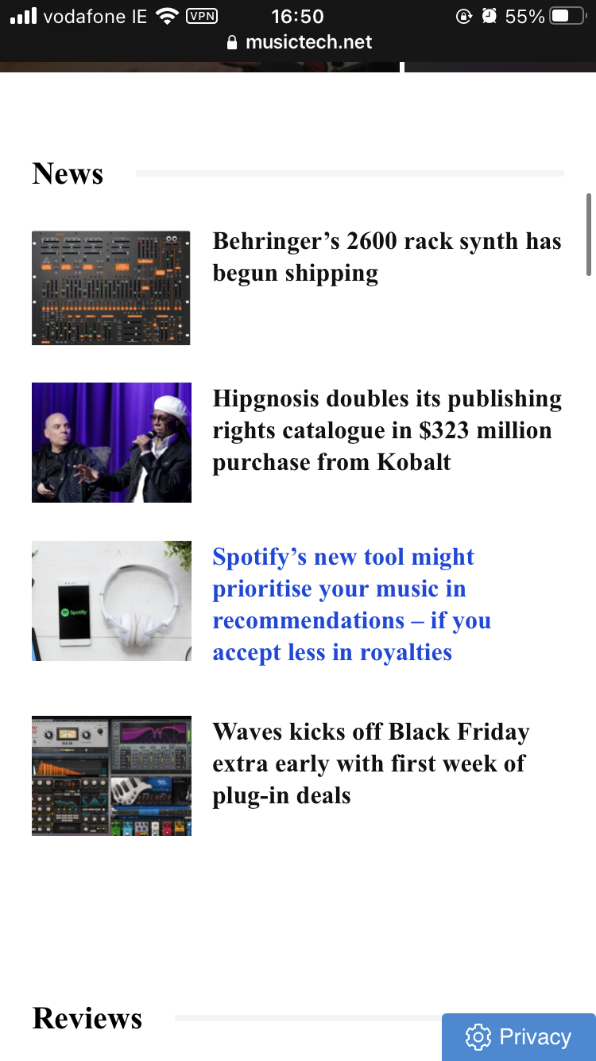

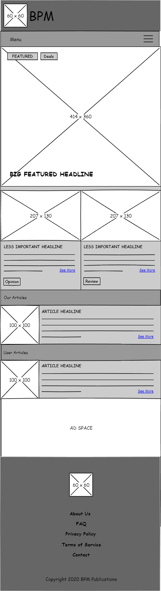

Article layouts for both desktop and mobile were simple enough to create simply by adapting these homepages, replacing the content with the article.

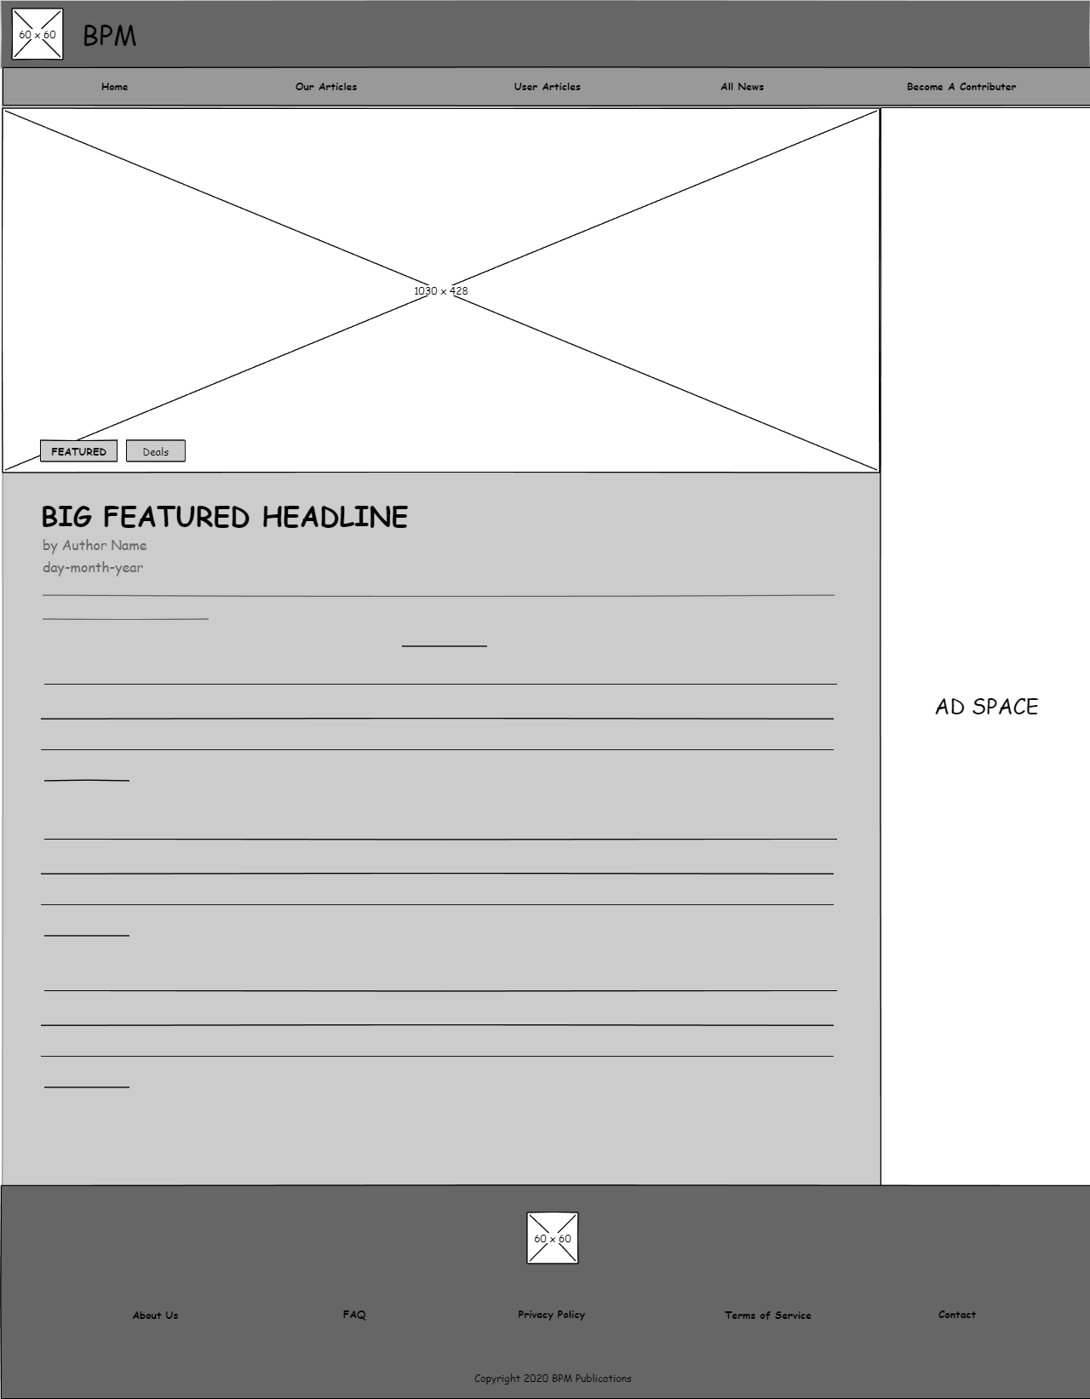

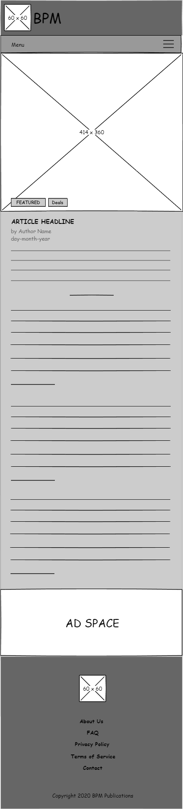

# Font

Traditionally, newspapers have used serif typefaces such as Times New Roman, and some news websites have continued this tradition into the digital.

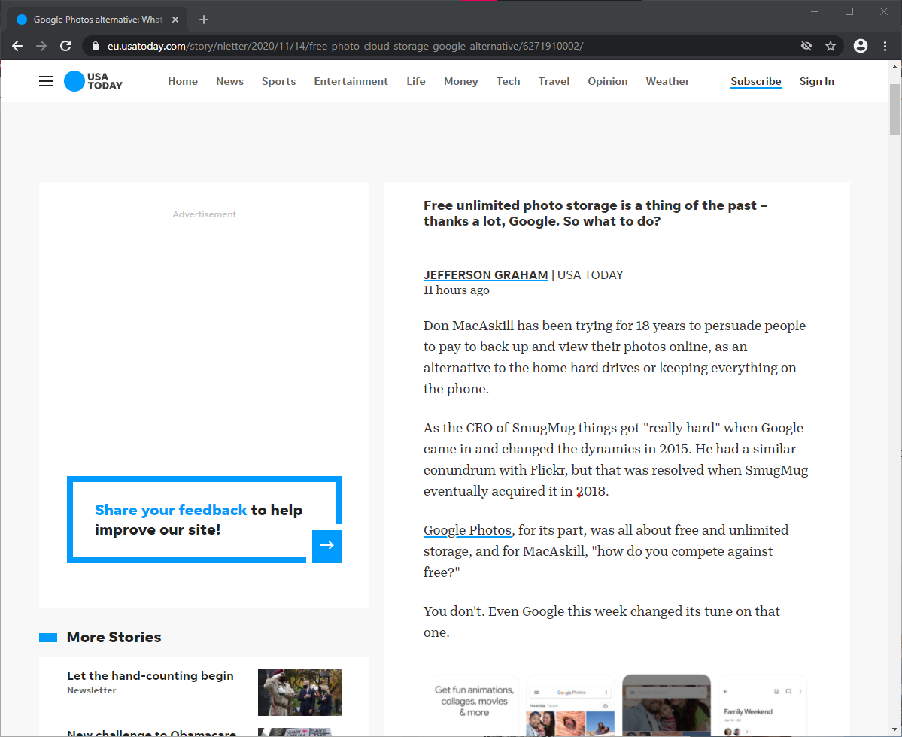

The idea of using a similar font did have its appeal – after all, it is these kinds of typefaces that are used to write musical terms on sheet music.



However, bearing in mind that the focus of my website was going to be music technology rather than music in the traditional sense, I decided that this was insufficient justification for choosing a typeface. Ultimately, to counteract the minor sacrifice of readability I made when choosing a darker colour scheme, I thought it best to use a sans-serif typeface, specifically Roboto, as it seemed a safe choice.

